Manual Test Plan for githubProfile App

**1 Introduction**

Github Profile App is going to display github information in Android platform. It has four pages, interacting with profile, followers, following, and repositories respectively. The page navigation can be either performed by bottom tabs, or by buttons.

**2 Launch**

Connect your android phone with the computer. Make sure it allows developer mode. Run the android studio, install the apk and the application will be on your phone.

**3 Profile Page**

When entering the app, the main page shown should be profile page as figure shown. There should be a avatar, user real name and log-in name, number of following, followers and repositories. It should also display email, website, biography, and created date as the format in figure

.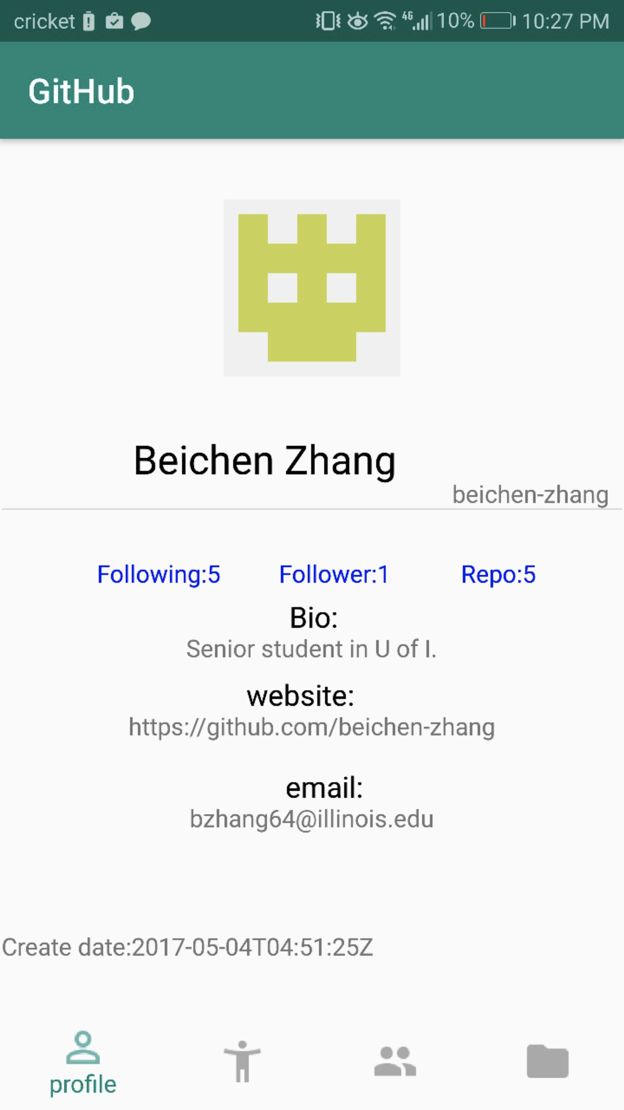

**4 Following and Followers**

Following and Followers Page Tab the bar item at the bottom of the screen, the page should navigate to the following and followers page. Both of them are in Scroll layout. Including the follower, following name and avatar image.

**Follower:**

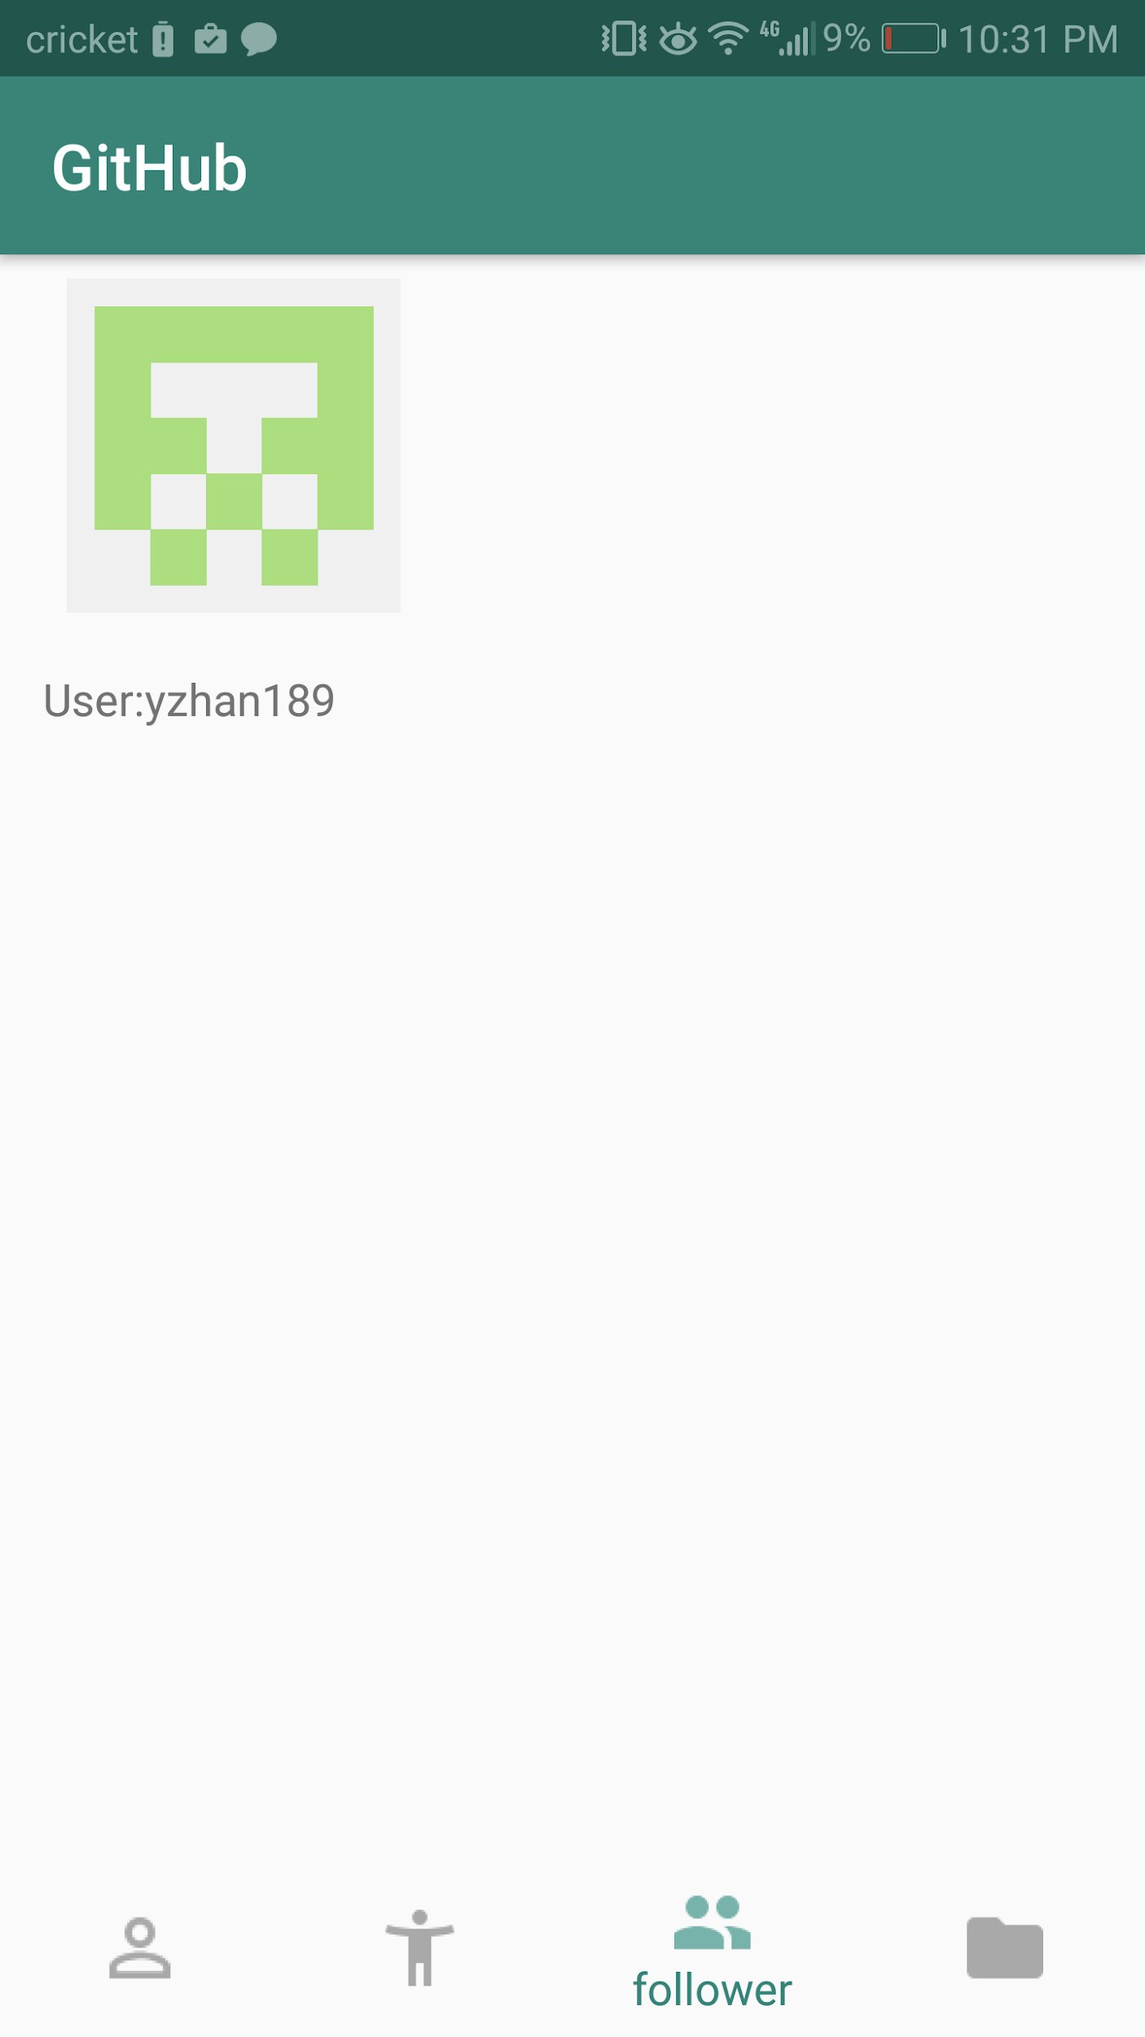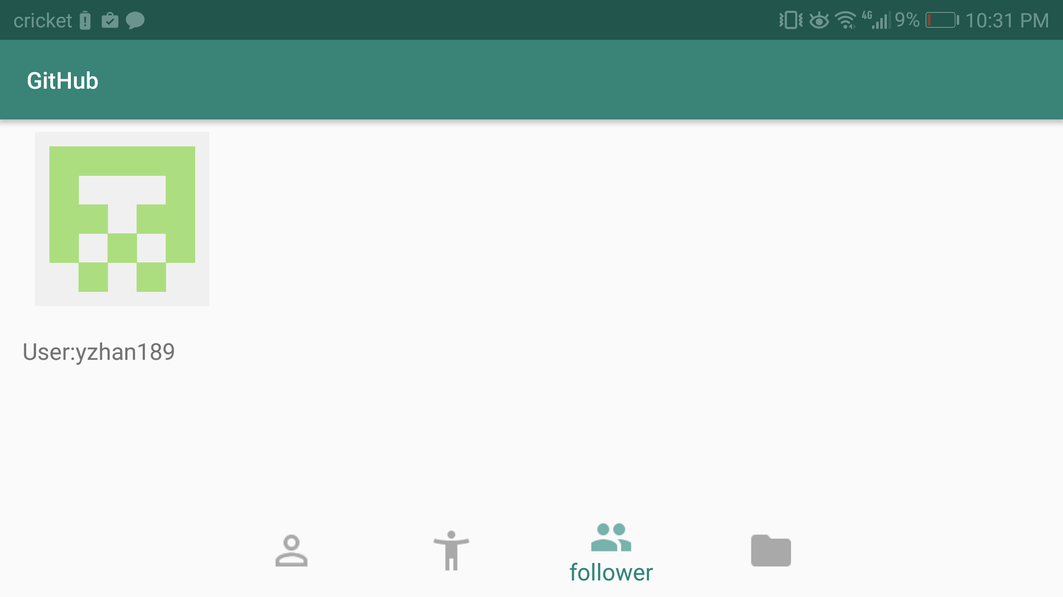

**Following:**

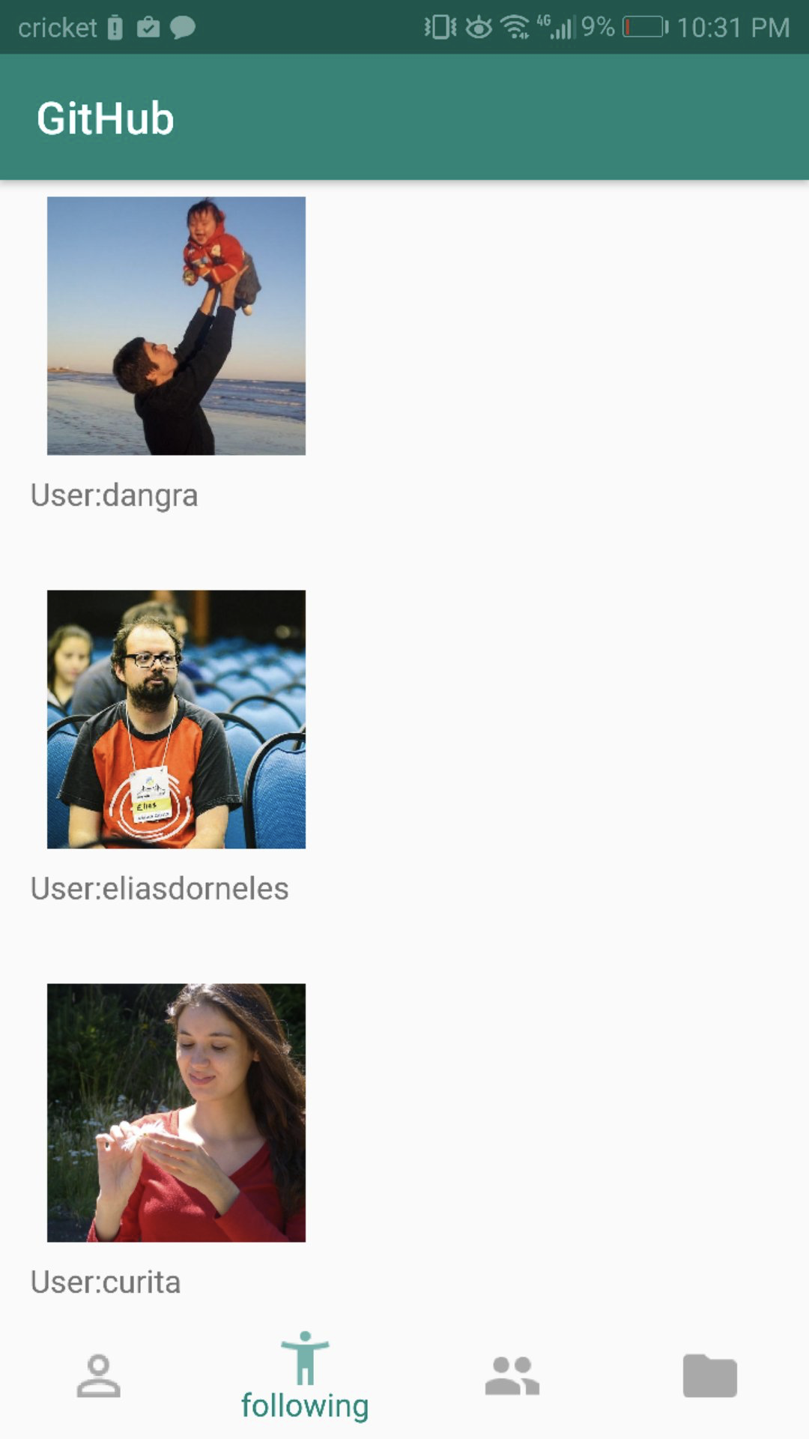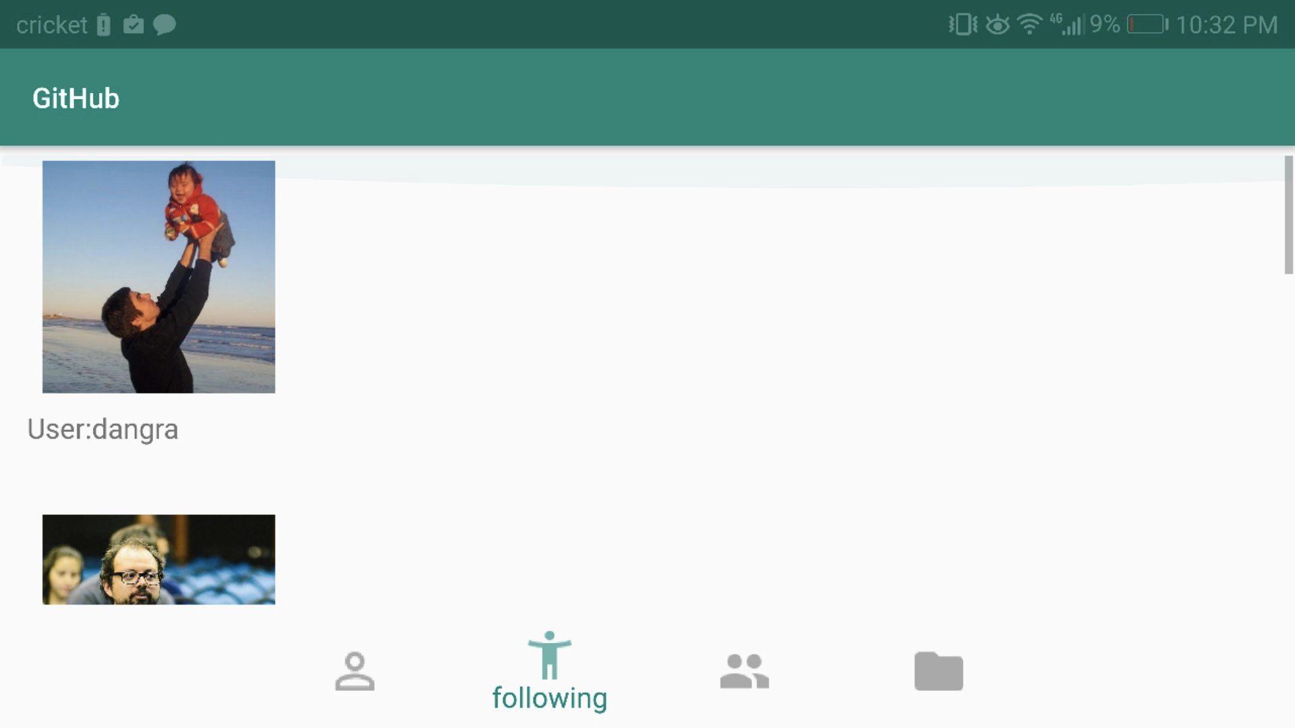

**Repository:**

Tab the bar at the bottom right of screen, it should navigate to repositories page as figure shows. There should be list of repositories. Click on the name of repo should give a web view of that web page as figure shows.

